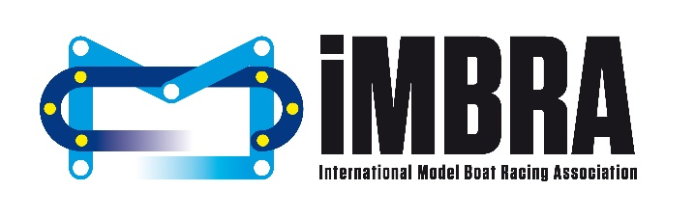
Dear Racers
The Committee Election and Open Meeting will be taking place at the World Championship in Egletons on Sunday 5th August 2018 at 19:30.
The following people will be standing for the roles listed below:
President – Ian Folkson (UK)
Vice President – Erich Costa (France)
Treasurer & Secretary – Lauren Morrison (UK)
Committee Member (4 posts available)
- Jan Wegeberg Smidt (Norway)
- Vladislav Krasovsky (Belarus)
- Christian Hof (Germany)
- Andrea Cavalli (Italy)
Junior Representative – Arturs Teteris (Latvia)
Previously the role of webmaster had been incorporated into a committee member position, however moving forwards Andy Coburn from the UK has kindly agreed to undertake this role along with his current role of iMBRA photographer. We think you will all agree that Andy’s skills behind the camera are fantastic and we cannot thank him enough for all the work he has done to date and continues to do in helping to publicise and promote our sport.

The following proposals have been received and will be voted on during the meeting.
Proposal 1 – submitted by Christian Hof (Germany)
Racing format for Offshore classes

IMBRA is set to be a worldwide association for model boaters all around the world. In several parts of the world the racing format is and ever was different. To make a move to have the possibility to make our „world“ championships more attractive to racers from overseas (mainly North America and Australia). Very often, the race leaders come out clearly after a few laps. Then it is only about lasting until the end. In many cases not even two or three boats finish and have to go round and round for minutes...

I propose the following:
Changing of the race time for all offshore classes. Instead of running 8min/12min the race format is very similar to the hydro classes. The idea is to have shorter but at the same time more interesting races.
• 8 laps per race
• milling time rules equal to hydro classes of 2:30min
• maximum time to complete a race must be defined
• points equal to hydro classes
• maximum 10 boats per heat

• two options for racing heats:
• smaller international / national races: 4 heats qualification, top 10 boats have two extra final heats the finalists will start with extra points in the final heat: (Nr.1 10 points, Nr.2 9 points, Nr.3 8 points and so on so no draws possible
• world championship: 4 qualifying heats. 4 final heats (same as hydro)

The rule change would mean the following:

Pro:
- more interesting and intense races
- shorter time period needed to hold a race for offshore classes and easier for organiser
- opening our rules for overseas competitors

Con:
- no class in-between 6-laps fast hydro racing and long endurance races

Neutral:
- new boats / boat designs will evolve

Details of this rule change may be discussed and worked out thoroughly.

Proposal 2 – submitted by Christian Hof (Germany)
Oval-Course design for hydro and offshore classes
Our 6-buoy „oval“ course that we have raced on so far is, to be honest, no real oval. Especially when the hydro boats are designed to go around nice round turns. When you closely watch many crashes that happen on our existing course they are due to the 3 buoys we have in one turn. The course does not invite you to go around smooth corners and to stay on your chosen line as it is intended by the rule. Changing this to 5 buoys per side would be a great advantage.
As an option this could be tested at some IMBRA-League races to wait for feedback from the racers. Then this rule can be fixed. Also it might make sense to only have a 10-buoy course compulsory for world championships, if the organisers of a weekend-race cannot handle the extra work. Exact position of the extra buoys can be discussed/determined.
The rule change would mean the following:
Pro:
- easier and more „organised“ course
- lines are easier to hold so less crashes
Con:
- Organiser must put out and maintain 10 buoys in total

Figure 1: shows a 10-buoy oval course

Figure 2: different lines driven with different courses

Proposal 3 – submitted by Evert De Ronde Jr (Netherlands)
iMBRA League Rules update
Endurance only:
a) at least 4 different countries must attend
b) at least 80 boats (in total) must attend the race
All leagues; Endurance, Hydro & Offshore:
c) the organisation hosting the event must be a member of iMBRA

End of Proposals

As stated previously the meeting will be an open meeting and everybody is welcome to attend. When it comes to voting each country will get one vote. We advise you to discuss the proposals prior to the meeting and elect a member of your team who will cast your countries vote.
We look forward to seeing you all soon
Kind regards
The iMBRA Committee

